Week 2- Spring Data JPA with Hibernate - 8013536

EXERCISE 1: Spring Data JPA - Quick Example

- Go to https://start.spring.io/
- Change Group as “com.cognizant”
- Change Artifact Id as “orm-learn”
- In Options > Description enter "Demo project for Spring Data JPA and Hibernate"
- Click on menu and select "Spring Boot DevTools", "Spring Data JPA" and "MySQL Driver"
- Click Generate and download the project as zip
- Extract the zip in root folder to Eclipse Workspace
- Import the project in Eclipse "File > Import > Maven > Existing Maven Projects > Click Browse and select extracted folder > Finish"
- Create a new schema "ormlearn" in MySQL database. Execute the following commands to open MySQL client and create schema.
- In orm-learn Eclipse project, open src/main/resources/application.properties and include the below database and log configuration.
- Build the project using ‘mvn clean package -Dhttp.proxyHost=proxy.cognizant.com - Dhttp.proxyPort=6050 -Dhttps.proxyHost=proxy.cognizant.com - Dhttps.proxyPort=6050 -Dhttp.proxyUser=123456’ command in command line
- Include logs for verifying if main() method is called.

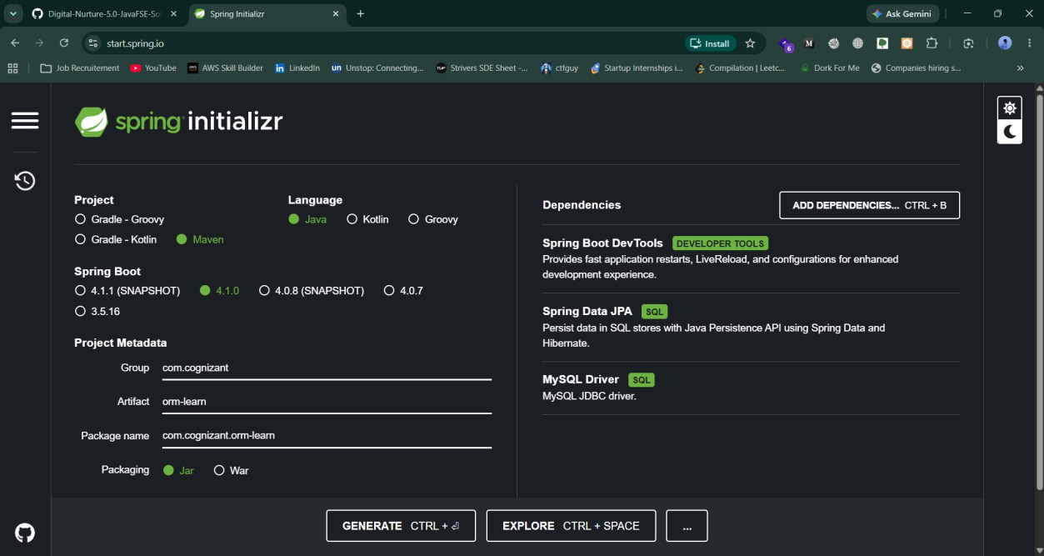

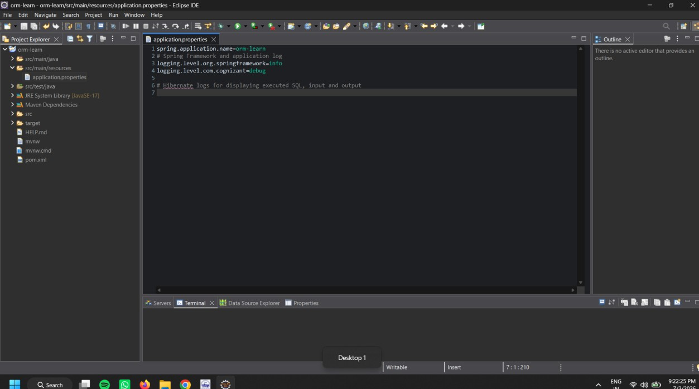
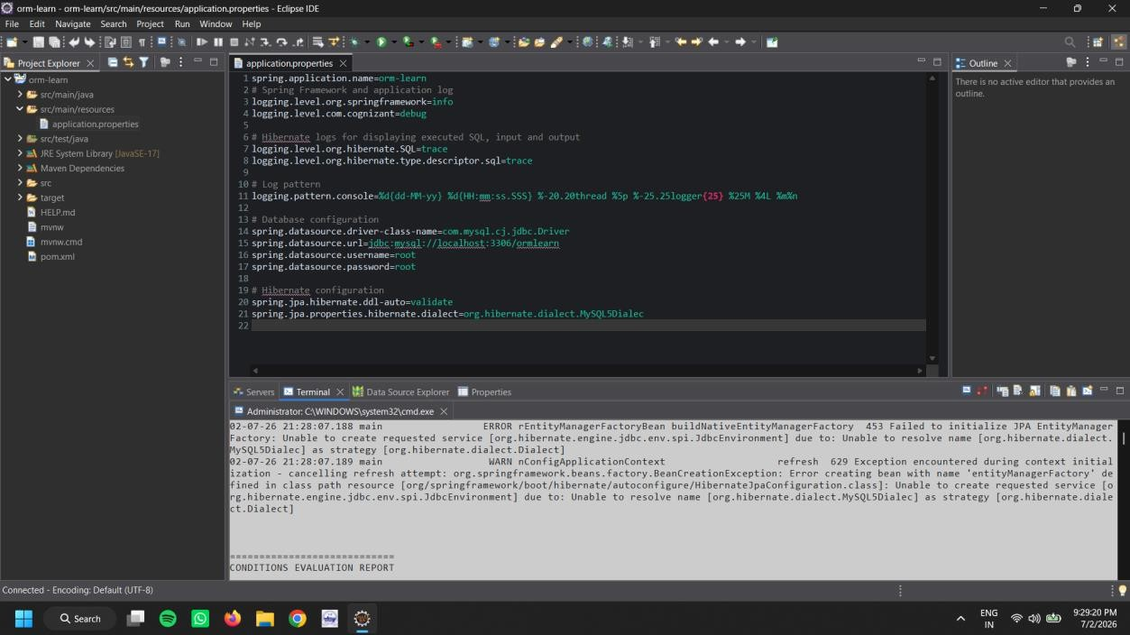

Persistence Class - com.cognizant.orm-learn.model.Country
- Open Eclipse with orm-learn project
- Create new package com.cognizant.orm-learn.model
- Create Country.java, then generate getters, setters and toString() methods.
- Include @Entity and @Table at class level
- Include @Column annotations in each getter method specifying the column name.

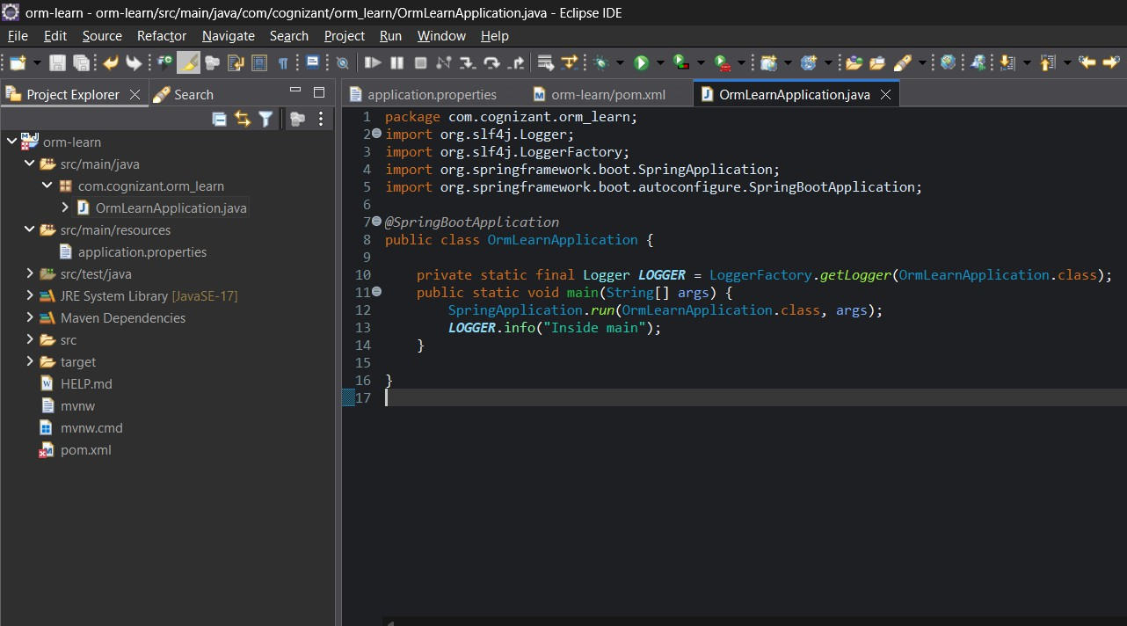

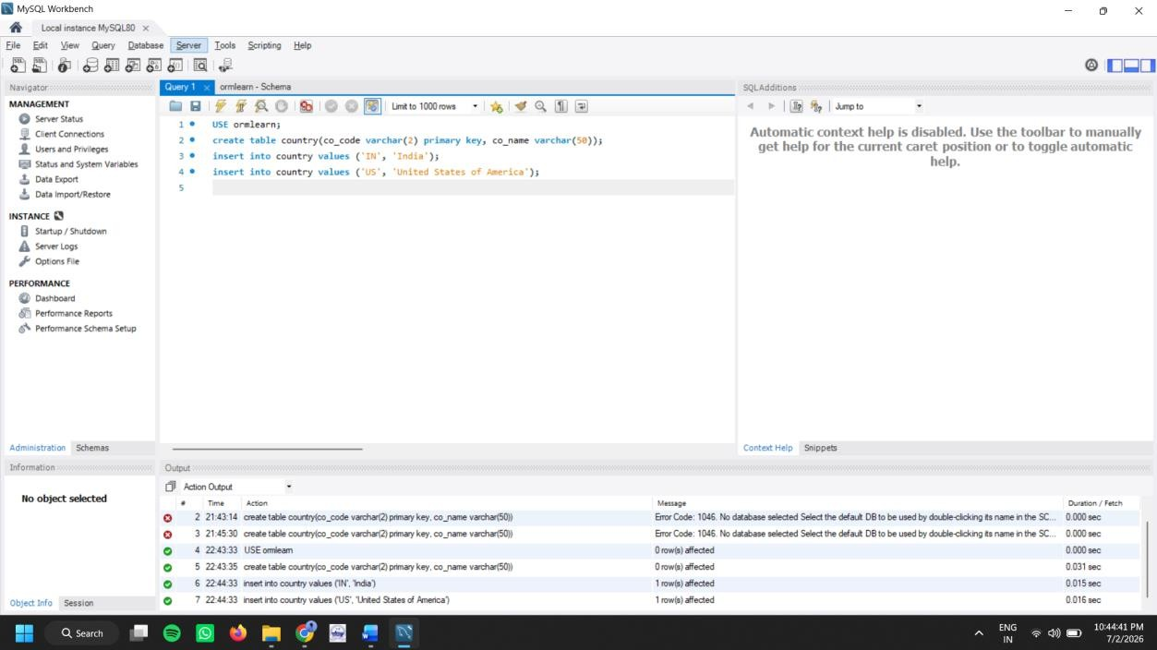

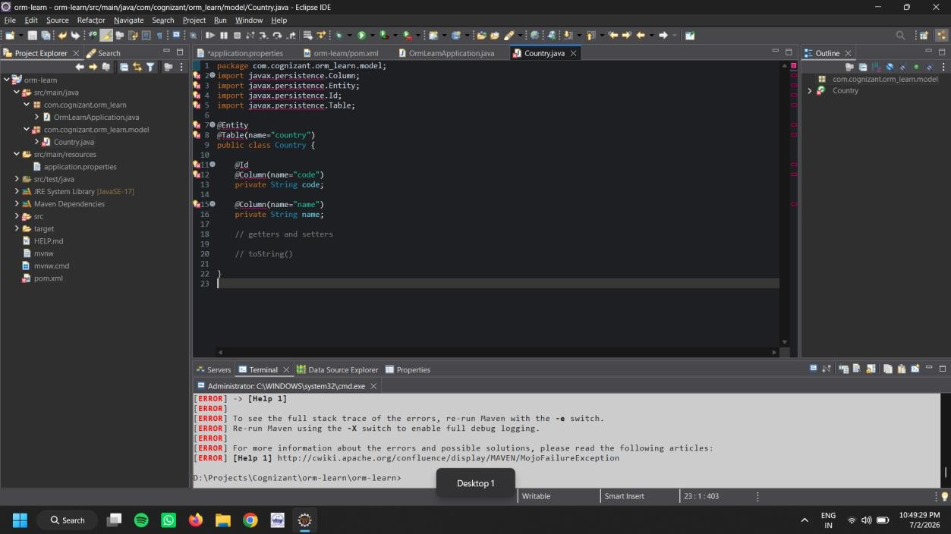

EXERCISE 2 Difference between JPA, Hibernate and Spring Data JPA
Java Persistence API (JPA)
- JSR 338 Specification for persisting, reading and managing data from Java objects
- Does not contain concrete implementation of the specification
- Hibernate is one of the implementation of JPA Hibernate
- ORM Tool that implements JPA Spring Data JPA
- Does not have JPA implementation, but reduces boiler plate code
- This is another level of abstraction over JPA implementation provider like Hibernate
- Manages transactions

Refer code snippets below on how the code compares between Hibernate and Spring Data JPA
Hibernate
/* Method to CREATE an employee in the database */
public Integer addEmployee(Employee employee){ Session session = factory.openSession(); Transaction tx = null;
Integer employeeID = null;

try {
tx = session.beginTransaction();
employeeID = (Integer) session.save(employee); tx.commit();
} catch (HibernateException e) { if (tx != null) tx.rollback(); e.printStackTrace();
} finally { session.close();
}
return employeeID;
}

Spring Data JPA
EmployeeRespository.java
public interface EmployeeRepository extends JpaRepository<Employee, Integer> {

}
EmployeeService.java @Autowire
private EmployeeRepository employeeRepository;

@Transactional
public void addEmployee(Employee employee) { employeeRepository.save(employee);
}

EXERCISE 3 Implement services for managing Country

An application requires for features to be implemented with regards to country. These
features needs to be supported by implementing them as service using Spring Data JPA.

- Find a country based on country code
- Add new country
- Update country
- Delete country
- Find list of countries matching a partial country name
Before starting the implementation of the above features, there are few configuration and data population that needs to be incorporated. Please refer each topic below and implement the same.

Explanation for Hibernate table creation configuration
- Moreover the ddl-auto defines how hibernate behaves if a specific table or column is not present in the database.
  - create - drops existing tables data and structure, then creates new tables
  - validate - check if the table and columns exist or not, throws an exception if a matching table or column is not found
  - update - if a table does not exists, it creates a new table; if a column does not exists, it creates a new column
  - create-drop - creates the table, once all operations are completed, the table is dropped

